Workflow Functional Document

Application: | NGERP-CENTRA
WorkFlow: | Quote To Cash
WorkFlow Item Name: | NTA AR Invoice with Charge

Description
This workflow used to create the NTA AR Invoice into the HQoW system with manual process

Work Flow Process:

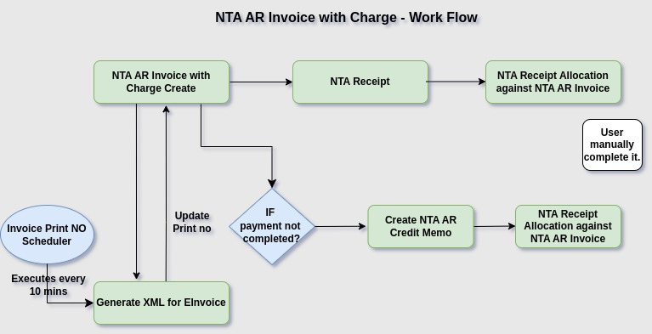

Business Rules:

- A Non-Trade Accounts Receivable (AR) Invoice is an invoice issued for transactions that are not related to the core business activities or sale of goods and services. These transactions may include items such as:
- Employee Advances: Amounts owed by employees for advances or personal expenses that need reimbursement.
- Rental Income: If a business has rental property or equipment rental income that’s not part of its main operations, it may issue a non-trade AR invoice.
- Miscellaneous Reimbursements: This includes reimbursements for out-of-pocket expenses or other non-operational transactions.
- Interest Income: If a company charges interest on loans provided to others (outside of trade operations), it may issue a non-trade AR invoice for the interest collected.
- Other Debtors: Amounts due from non-trade debtors or customers, such as those from investment-related transactions or refunds.
- A Non-Trade Receipt is created against the Vendor,NTA Receipt is a cash or bank receipt from sources other than the core business operations or sale of goods and services.
- After that allocation will happened for the respective NTA Receipt and NTA AR Invoice

